# **CSE 620: Advanced Computer Architecture**

# **Project: HDL Test bench**

**Digital System Modeling using HDL**

**Half Adder Test bench**

**Deliverables:**

1. **Design example name and location in the slides**

Design Example name: Half Adder.

Location: Example 9, page 15 VHDL Combinational logic modeling slides.

The code is converted to Verilog and attached.

1. **Test strategy**
2. Manually Generate a test vectors in the test bench to cover all possible cases for inputs A and B.
3. Compare results in S and C with the test vector and adjust a “Fault_Indicator” signal to be used as flag.
4. Observing “Fault_Indicator” signal if equals to 1 then fault detected.
5. Expected results: A, B, S, C should follow this truth table of half adder

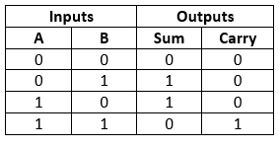

Actual results: the results match and no fault detected.

1. The expected and actual are the same, thus verifies the functionality of the design.
2. **Simulation results**

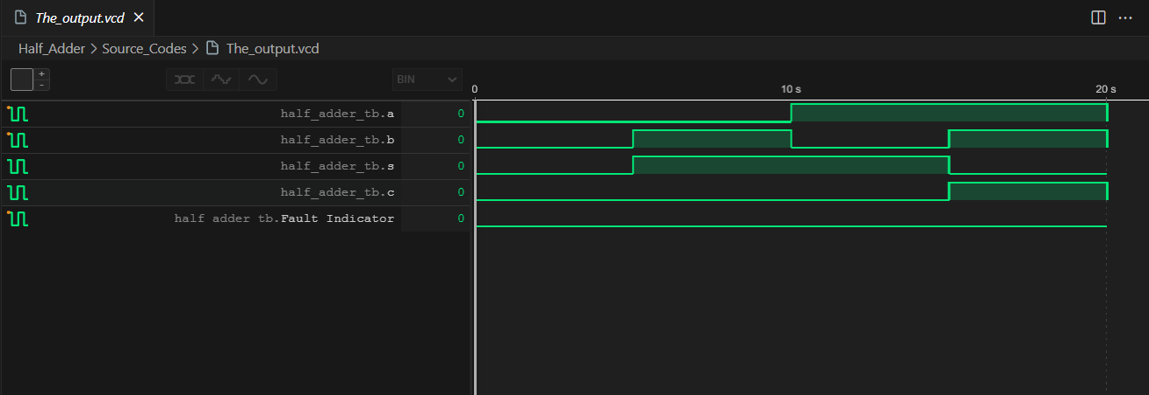

1. **Names of all used tools**

* I Verilog (Verilog open source Compiler)
* Vscode (Code Editor)
* Wave tracer extension for VSCode
* Python
* PowerShell

***End of Assignment***